Sri Lanka Institute of Information Technology



Assignment
IT3051 - Fundementals of Data Mining
Technical Report

Group: Mine4Data (DS. Y3S2.01.01)
Airbnb Listing Price Prediction

Student Names and Registration Numbers:
- IT23404328

Introduction and problem definition

Dataset
- Dataset Name: Airbnb Price Dataset Original Source: Compiled from Airbnb listing data across six major US cities (New York City, Los Angeles, San Francisco, Washington D.C., Chicago, and Boston).
- Published on Kaggle by Rupinder Singh Rana.
- Platform: Kaggle
Dataset URL/ Download source and citation
URL: https://www.kaggle.com/datasets/rupindersinghrana/airbnb-price-dataset
Citation: Rana, R.S. (n.d.). Airbnb Price Dataset. Kaggle. Retrieved September 2026, from https://www.kaggle.com/datasets/rupindersinghrana/airbnb-price-dataset
Licence: Publicly available on Kaggle for academic and research use
Dataset Description and problem
The Airbnb Price Dataset contains approximately 74,111 short-term rental listings across six major cities in the United States: New York City, Los Angeles, San Francisco, Washington D.C., Chicago, and Boston. Each record represents an individual Airbnb listing and includes property characteristics, host information, location data, review metrics, and booking policies.
The dataset was originally compiled from Airbnb's platform data and has been curated for price prediction tasks. The target variable (log_price) is the natural logarithm of the nightly listing price in USD, a standard transformation applied to handle the heavy right-skew typical of rental price distributions.
Real-World Problem: New Airbnb hosts often struggle to set a competitive nightly price for their listings. Pricing too high leads to low occupancy; pricing too low leaves revenue on the table. A data-driven pricing recommendation tool would analyse comparable listings based on property attributes, location, and amenities to suggest an optimal nightly rate — helping hosts maximise occupancy and revenue while remaining competitive in their market.
This project builds a supervised regression system that suggests a nightly price for an Airbnb listing from its property, location and booking details.
Task type. Supervised regression on a continuous target. Success is measured by RMSE on the log scale (primary), supported by R², MAE in dollars and the share of listings priced within ±25% of the real price.

Assigned scenario and user/stakeholder requirements

The scenario is a data-driven pricing recommendation tool: a host enters property details and receives a suggested nightly price based on comparable listings. The tool recommends; it does not set prices or value property.

Stakeholder | Decision Supposed | What they need from the system
New Airbnb hosts (primary user) | What nightly price to set for a new listing | A dollar price from details they know before any guest books, with no reviews or history required
Existing hosts | Whether to adjust price after upgrades or market changes | A quick re-estimate when bedrooms, amenities or policies change
Airbnb pricing teams | Which factors drive price across cities | Interpretable drivers (room type, capacity, location, amenities) and per-city error levels
Real-estate investors | Short-term rental income potential of a property | A typical nightly rate for a property profile in a given city

Functional Requirements
- Accept listing inputs through a form: city, property type, room type, neighborhood, bedrooms, beds, bathrooms, accommodation, amenities, cancellation policy, cleaning fee and instant bookable.
- Apply exactly the same preprocessing used in training, predict log_price, and return the price as "Suggested nightly price: $XXX".
- Use only features a host can supply for a brand-new listing (the deployable "listing" feature set), so no reviews or host history are needed.
- Show a typical price with a range, and warn that very cheap and luxury listings are less reliable.
Non-Functional Requirements

- Accuracy: clearly beat a mean-price baseline (CV RMSE 0.719) and price most listings within ±25%.
- Speed: return a prediction in well under a second, so the model must be fast at inference.
- Reproducibility: fixed train/test split and random seed (42) shared by every notebook and team member.
- No leakage: preprocessing fitted on training data only; test set used once, for the final model.
- Ethics: framed as a market-reflective recommendation, not a property valuation; no personal data stored.

Dataset identification, source, citation, and validation

The project uses the public Airbnb Price Dataset from Kaggle: 74,111 listings and 29 columns covering six US cities, with log_price as the target.
Item | Detail
Dataset name | Airbnb Price Dataset
Publisher / platform | Rupinder Singh Rana, Kaggle
URL | kaggle.com/datasets/rupindersinghrana/airbnb-price-dataset
Coverage | New York City, Los Angeles, San Francisco, Washington D.C., Chicago, Boston
Size | 74,111 rows × 29 columns (single CSV)
target
  Target | log_price = ln(nightly price in USD), continuous
Licence | Public on Kaggle for academic and research use
Validation of the dataset
- Source credibility: a widely used public Kaggle dataset compiled from Airbnb platform data; it contains no host names, guest details or contact information (no PII).
- Schema check: all 29 expected columns present with the types listed in the proposal; id, name, description and thumbnail_url were identified as non-predictive.
- Target check: log_price behaves as a log of price (e.g. $150 → 5.01, $75 → 4.32); exp(log_price) returns plausible nightly prices from $10 to about $2,000.
- Row integrity: after cleaning, 74,109 listings remained and were split 80/20 into 59,287 training and 14,822 test rows; a saved split_ids.csv file confirms every notebook uses exactly the same split.
- Representativeness check: the five cross-validation folds have near-identical target mean (4.77–4.79), standard deviation (0.71–0.73), NYC share (43–44%) and entire-home share (55–56%).
- Known limitations: the 2017 snapshot does not reflect current prices, and review and host-history columns are not available for a brand-new listing (handled in Section 6).

Data understanding and EDA
EDA showed that price is driven first by room type, then location, then amenities and size, and that the raw price is heavily skewed, which justifies modelling log_price.
Target distribution. Raw nightly prices cluster between $50 and $300 with a long luxury tail up to about $2,000. On the log scale the distribution is close to normal (training mean 4.78, standard deviation 0.72, i.e. a typical price of about $119). Price deciles in the training set run from $10–50 at the bottom to $300–1,999 at the top.
Composition of the training set (59,287 listings)

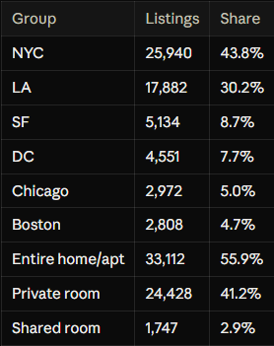
NYC and LA hold 74% of listings, so location effects are learned most reliably there. Shared rooms are rare (under 3%), which later makes them the hardest segment to price.
Key EDA findings
- Room type separates price levels most strongly: entire homes cost far more than private rooms, which cost more than shared rooms.
- Location matters at several levels: city, neighbourhood, and distance to the city centre. Prices peak about 1–2 km from the centre and fall with distance.
- Size variables (accommodates, bedrooms, beds, bathrooms) rise with price but are strongly correlated with each other, which signals multicollinearity for linear models.
- Amenities are stored as a text set (e.g. {TV, Wifi, Kitchen}); specific amenities carry more signal than the raw count.
- Missing values appear in review_scores_rating, host_response_rate, first_review/last_review (listings never reviewed), bathrooms, bedrooms, beds and zipcode.
- Outliers exist in accommodates (16+), bathrooms (8+) and beds; they are mostly genuine large properties, not errors.
- Leakage risk: number_of_reviews and review_scores_rating only exist after a listing has been active, so they cannot be used for a brand-new listing.
Figures to insert from Notebook 01: raw vs log price histograms, price by room type and city (box plots), correlation heat-map of numeric features, missing-value bar chart, and a map of listings coloured by price.

Data cleaning and preprocessing

Data cleaning and preprocessing
Cleaning reduced the data from 74,111 to 74,109 listings, and all learned preprocessing (imputation, encoding, scaling) runs inside an sklearn Pipeline so it is fitted on training folds only.
Cleaning steps (src/preprocessing.py, clean_and_engineer)
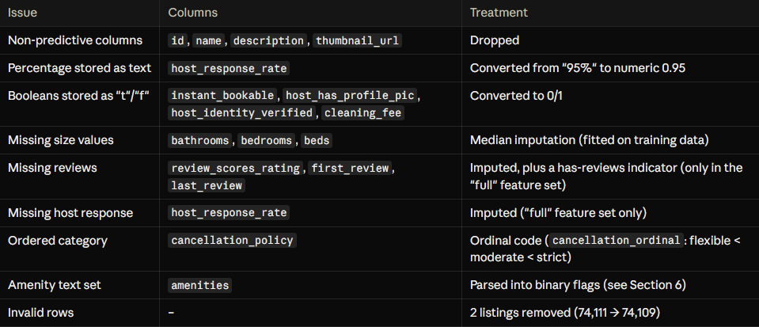

Train/test split. An 80/20 random split (random_state = 42) gave 59,287 training and 14,822 test listings. Listing IDs per split are saved to data/processed/split_ids.csv. The test set stayed locked until the final model was chosen.
Two preprocessing pipelines
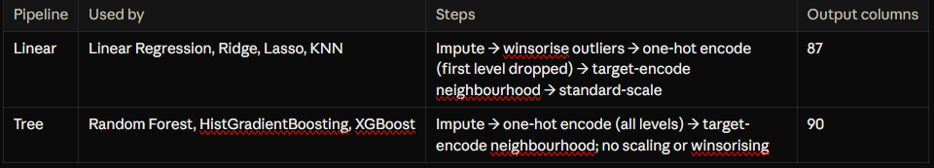
Linear models and KNN need scaling and outlier capping because penalties and distances depend on magnitude. Trees only compare values with thresholds, so scaling is unnecessary and outliers do little harm.
Leakage prevention. Preprocessing is the first step of each Pipeline, so in every cross-validation fold the medians, target encodings and scalers are learned on the four training folds only. The high-cardinality neighbourhood column is target-encoded inside the fold for the same reason.

Feature engineering and feature selection

Engineered features lower the final model's CV RMSE from 0.4002 to 0.3834; the amenity flags carry most of that gain, and keeping all 90 features beats any top-k subset.
Engineered features
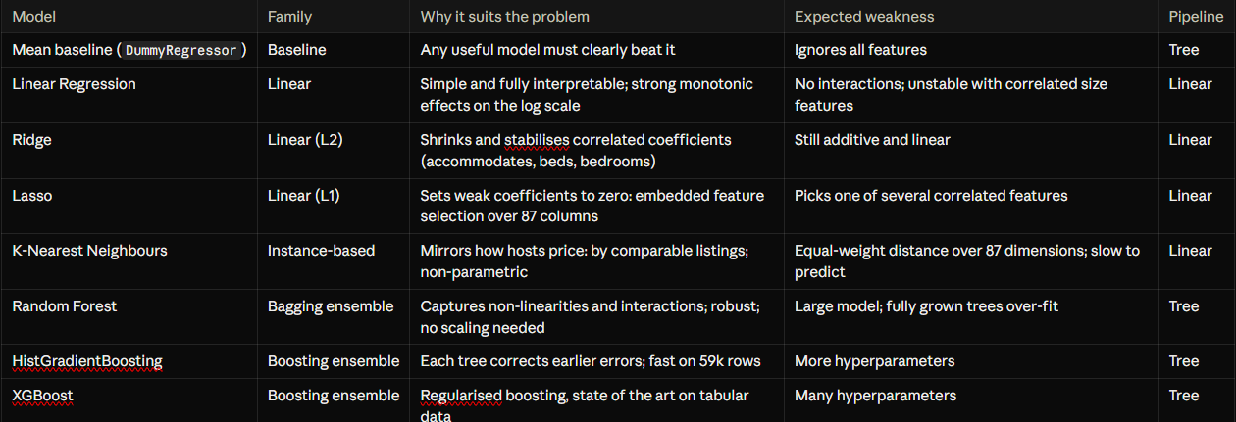

Fair comparison set-up. All models used library defaults in the first round, so the algorithms, not the tuning effort, were compared. Two documented exceptions: Lasso used alpha = 0.001 (the default of 1.0 removes every feature) and Random Forest used max_features = 1/3 (Breiman's standard choice for regression). Every model was trained on the same deployable "listing" feature set.
Validation strategy. 5-fold shuffled cross-validation on the 59,287 training listings (random_state = 42), with identical folds for every model and preprocessing refitted inside each fold. A time-based split was not needed: the data is a single 2017 snapshot and the task is pricing now, not forecasting.
Metrics
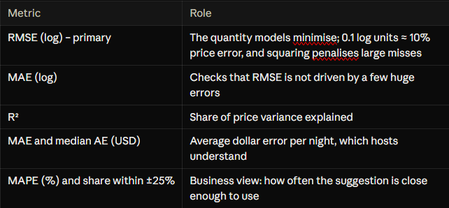

Model evaluation and comparison

At default settings the three tree ensembles tie for best (CV RMSE about 0.393, R² 0.701), clearly ahead of the linear models (0.417), KNN (0.447) and the mean baseline (0.719).
5-fold CV results, default settings, listing features (sorted by RMSE)
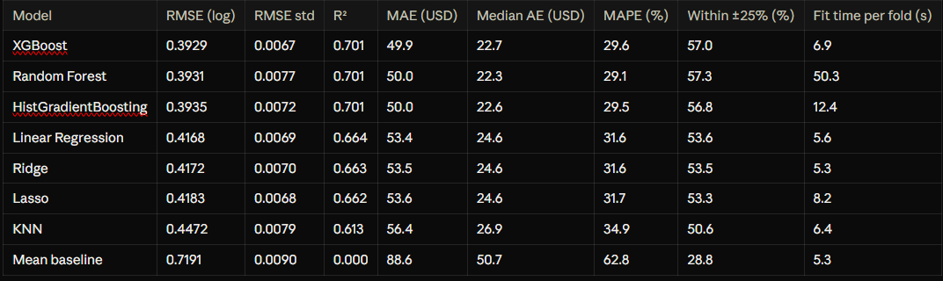
Is the ranking reliable? Because all models share the same folds, a paired fold-by-fold comparison was made. XGBoost beats the linear models by 0.024 and KNN by 0.054 on all 5 folds, with a spread of only 0.002, so these gaps are systematic. Against Random Forest and HistGradientBoosting the difference is 0.000–0.001 and XGBoost wins only 2 and 3 folds, so the three ensembles are tied at defaults. No t-test was used: folds share training data, so it would overstate confidence.
Over- and under-fitting (train R² vs CV R²)
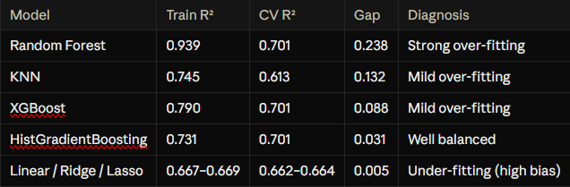

Why the ensembles win. Learning curves show Ridge's train and validation errors meet at about 0.41–0.42 even with 4.7k rows, so more data barely helps (bias-limited). XGBoost's validation error keeps falling from 0.435 to 0.393 as data grows from 4.7k to 47k rows (variance-limited). Price has non-linear effects and interactions, and 59k listings is enough to learn them.
Where errors come from
- Price range: all models over-predict the cheapest decile (about +0.33 to +0.42 log units) and under-predict the most expensive (about −0.45 to −0.54), i.e. regression toward the mean. XGBoost is closest to zero at both ends.
- City: NYC (27.2% MAPE) and LA (28.2%) are easiest; DC (43.0%) and SF (33.9%) are hardest.
- Room type: shared rooms are hardest (37.0% MAPE, only 1,747 listings). XGBoost beats Linear Regression in every segment.
Feature-set experiment. With the "full" set (adding reviews and host history), R² rises by 0.015 (Linear) to 0.023 (XGBoost), but the ranking does not change. All 12 Stage 6 runs are recorded as experiments S6-01 to S6-12 in results/stage6_experiment_log.csv.
Figures to insert: model comparison (3 panels), train vs validation dumbbell chart, RMSE by fold, learning curves, residuals by price decile.

Hyperparameter tuning and optimization

Tuning made XGBoost the clear leader (CV RMSE 0.3929 → 0.3834, R² 0.716) and separated the three ensembles that were tied at defaults; the family order did not change.
Search design. Grid search was used where there are one or two parameters with few sensible values; randomised search was used for the ensembles, where a full grid over 6–8 interacting parameters would need thousands of fits (Bergstra and Bengio, 2012). Every search:
- minimised 5-fold CV RMSE (log) on the training set only, using the same folds as Stage 6;
- searched the whole Pipeline, so preprocessing was refitted inside every fold;
- cached each fold's fitted preprocessor with joblib.Memory to save time without leaking validation data;
- used random_state = 42 and saved every candidate to results/stage7_search_<model>.csv.

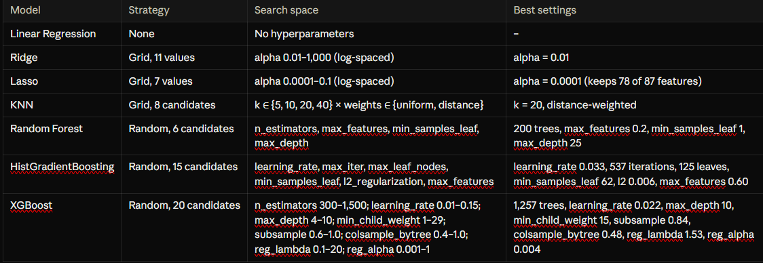
Log-uniform distributions were used for learning rate and regularisation strengths because they act multiplicatively.
Tuned vs baseline (5-fold CV RMSE, log)
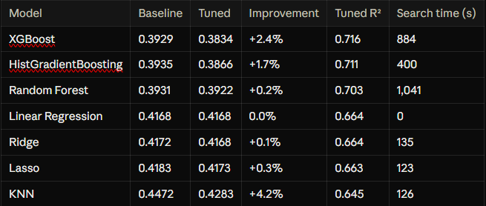

What tuning revealed
- Linear models: Ridge error is flat (about 0.417) from alpha 0.01 to 100, confirming they were bias-limited, not over-fitting. Lasso shows embedded selection: about 54 features remain at alpha 0.001 with almost no loss.
- KNN: a U-shaped validation curve (best at k = 20) shows the bias-variance trade-off; distance weighting wins at every k. Even tuned, KNN (0.428) trails XGBoost (0.383).
- Random Forest: all six candidates land within 0.3922–0.3945, so defaults were already near-optimal.
- Boosting: the best candidates use small learning rates (0.02–0.05) with many trees and deep but regularised trees; learning rates of 0.1 or more give the worst results (about 0.396–0.400).
Other optimisation experiments. Averaging the tuned boosting models gave 0.3831 and averaging all three ensembles 0.3834, a gain of at most 0.0004: the models make very similar errors, so there is little to cancel.
Caveat. The tuning budgets were small (6, 15 and 20 candidates), and a best-of-N CV score is slightly optimistic. The held-out test result in Section 10 shows no sign of this.

Final model selection and justification
The final model is tuned XGBoost on the listing features. On the untouched test set it scores RMSE 0.3808, R² 0.711 and MAE $47.81, and prices 59.1% of listings within ±25%.
Selection rule (fixed before the test set was used). Choose the single tuned model with the lowest CV RMSE on the deployable features. An ensemble replaces it only if it lowers CV RMSE by more than 0.005, about the fold-to-fold noise. The best blend gained only 0.0004, so XGBoost alone was kept.
Selection criteria

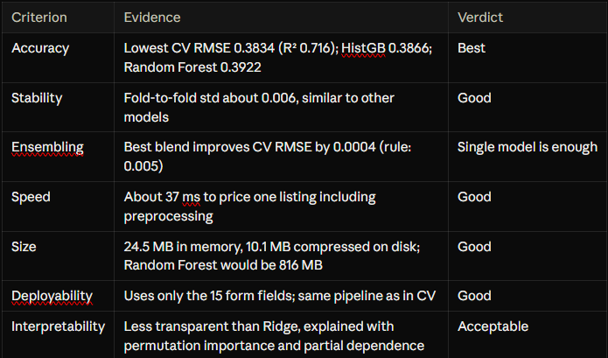
Why not the alternatives. Linear models are interpretable but 0.033 worse in RMSE (about $4.8 more error per night). Random Forest is less accurate, slower (98 ms per listing) and 33 times larger. HistGradientBoosting is a strong, smaller fallback (8.9 MB) with 0.003 higher CV error. An ensemble adds complexity for no measurable gain.
Final test-set evaluation (used once)
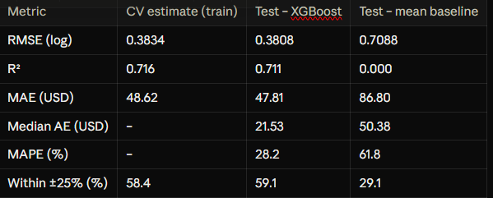
Test and CV results agree closely, so the CV procedure was honest and tuning did not over-fit the folds. The model cuts average dollar error by about 45% compared with the baseline. Scored after the decision was locked, every tuned model's test RMSE is within 0.0034 of its CV value and the ranking is unchanged. Residuals are centred near zero (mean −0.006, std 0.381).
Error by price band (test set)
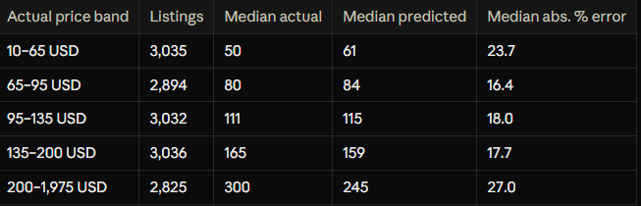
The middle 60% of listings have 16–18% median error; budget and luxury listings are less reliable, so the app shows a price range and a warning for them.
What the model relies on (permutation importance, test RMSE increase when shuffled)
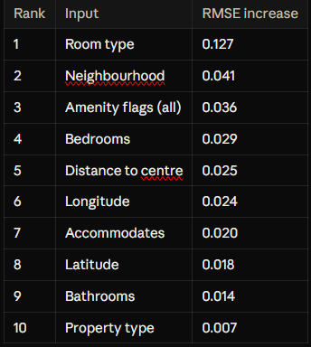
Price is set first by the kind of space, then by location, then amenities, then size. Partial dependence agrees with intuition: the average predicted price rises from about $136 for 1 guest to $188 for 10 guests, and peaks around 1–2 km from the city centre (about $167) before falling to about $126 beyond 30 km.
Saved for deployment. The full pipeline (preprocessing + tuned XGBoost) is saved as models/final_model.joblib (10.1 MB) with final_model_metadata.json (form fields, hyperparameters, metrics, library versions). A reload test priced a 2-bed Williamsburg NYC apartment at $183, a private room in the same flat at $80 and the same apartment in Venice, LA at $199, and matched the in-memory model exactly.

